Neurocube: A Programmable Digital Neuromorphic Architecture with High-Density 3D Memory

Corresponding author

Duckhwan Kim∗, Jaeha Kung∗, Sek Chai†, Sudhakar Yalamanchili ∗, and Saibal Mukhopadhyay∗

∗School of Electrical and Computer Engineering, Georgia Institute of Technology, Atlanta, Georgia, USA

†SRI International, Princeton, New Jersey, USA

Keywords

Neural nets; Neurocomputers; Neuromorphic computing;

Hybrid Memory Cube，Memory Centric Computing，In-memory Neuromorphic Processing

Summary

*Challenge*

Neural network is highly parallel, with opportunities to exploit data and thread level parallelism. However the overall system performance is often limited due to insufficient memory bandwidth and network latency. Low operational density (ops/byte), poor spatial locality, and massive parallelism serve to stress **memory bandwidth**.

Early on-chip cache solutions were not scalable to large neural networks or complex applications over large data sets, and even the use of high density eDRAM on-chip cache memory cannot support large input image sizes and/or deeper leaning networks on-chip underscoring the pressure on **off-chip memory bandwidth**.

*Contribution*

This paper introduces the Neurocube: a programmable, scalable, power efficient digital architecture platform for computing neuro-inspired algorithms. The approach is based on:

1. **In-memory neuromorphic processing**. The Neurocube integrates a fine grained, highly parallel, **compute layer within a 3D high-density memory package**, the hybrid memory cube (HMC)
2. **Memory-centric neural computing (MCNC)**. The data-driven nature and statically known memory access patterns of neuro-inspired algorithms is exploited to implement a programmable memory system to drive data flow enabled compute units. **No traditional instruction set model is used** in order to improve energy and compute efficiency.
3. **Programmable Neurosequence Generator**. Host programming interface is a set of memory-based **programmable state machines** (neurosequence generators) that exposes abstractions for connectivity and synaptic weights as the vehicle for programming different neural nets.

The approach also includes a NoC design.

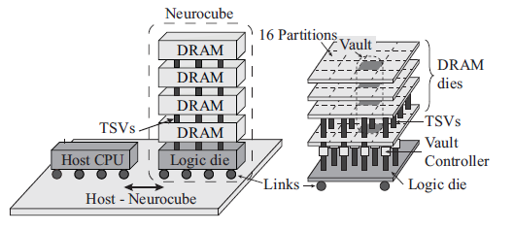

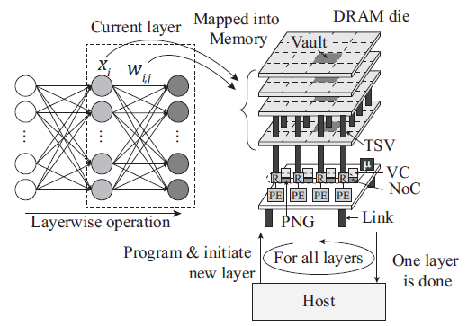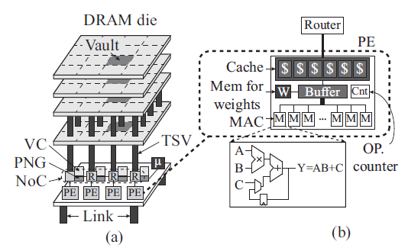

*Result*

The performance and power of Neurocube is analyzed for both training and inference of ConvNN (Scene Labeling). Neurocube synthesized with 15nm can deliver throughput up to 132GOPs/s during inference and 127GOPs/s during training within a compute power envelope of 3.4W in 15nm FinFet. The simulations project ∼4X improvement in computing power-efficiency (GOPs/s/W) over reported GPU based implementation while providing the programmability and scalability advantages over ASIC/FPGA platforms.

*Comments*

The author used Hybrid Memory and In-Memory Computing to solve the well-known memory wall problem in NN. It seems to be a good methods to get rid of on-chip cache limitation and complex memory hierarchy designing (NoC includes cache through), but the usage of HBM device make it hard to test in real world. The Programmable Neurosequence Generator (PNG) are only focused on Dense and Conv layer in the paper, it’s not clear if PNG can handle all possible kind of layers, and how flexible and programmable is the system.